V ^{th} International Symposium
“Design and Synthesis of Supramolecular
Architectures”

October 12–16, 2009
Kazan, Russia

A.E.ARBUZOV INSTITUTE OF ORGANIC & PHYSICAL CHEMISTRY
KAZAN STATE UNIVERSITY

http://iopc.knc.ru/conferences/supra5

FIRST CIRCULAR
The Organizing Committee is pleased to invite you to participate in the Vth International Symposium “Design and Synthesis of Supramolecular Architectures”, which will be held in Kazan (Russia), October 12–16, 2009. The Symposium will be focused on the all aspects of supramolecular chemistry and related fields of nanotechnology and advanced materials.

LOCATION AND TIME

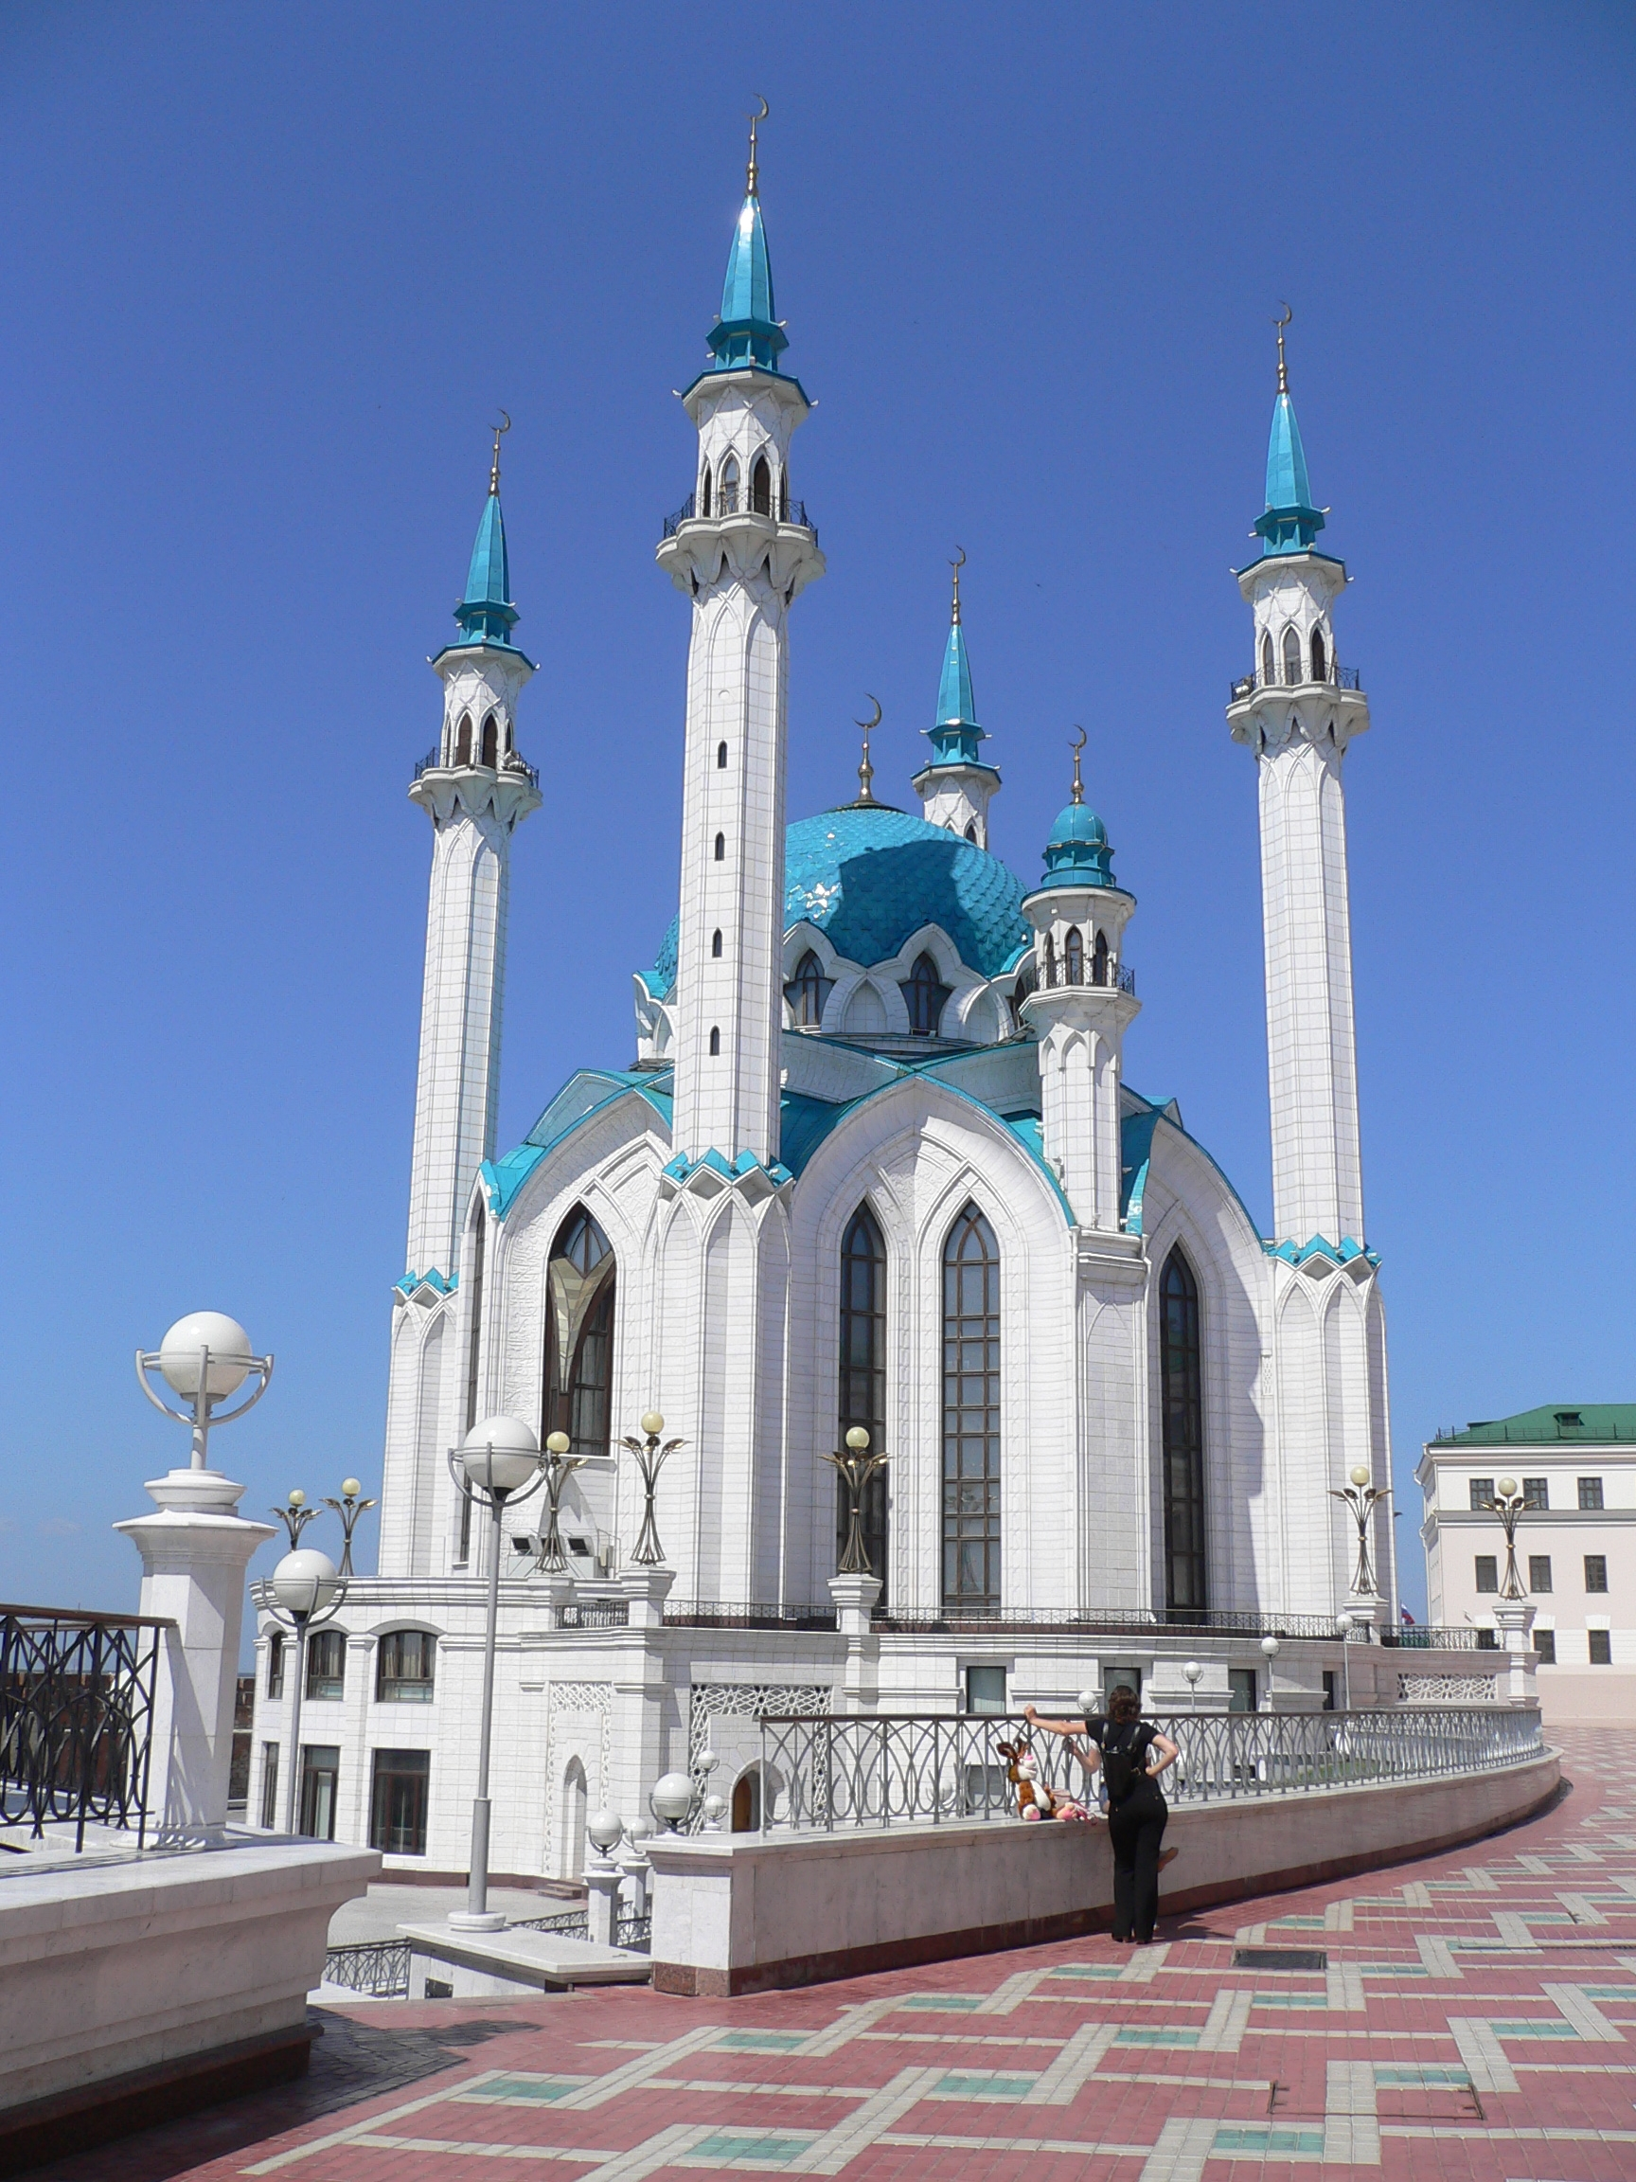

The Symposium is organized by A.E.Arbuzov Institute of Organic and Physical Chemistry (Kazan, Russia) of the Russian Academy of Sciences and Kazan State University. It will be located in the Cultural Center of Kazan State University.
Arrival day is October 11, 2009. The scientific program will start on Monday afternoon, October 12, 2009 and the last scientific session is prelimenary scheduled on Thursday, October 15, 2009.

Kazan is the capital of Tatarstan Republic and is situated along the Volga River in the European part of Russia. City is within 800 km to east from Moscow. Kazan is one of the oldest university’s cities and large scientific and cultural center of the Russia. This place is associated with the beginning of Russian organic chemistry and the names of outstanding chemists such as K.K.Klaus, N.N.Zinin, A.M.Butlerov, V.V.Markovnikov, A.M.Zajtsev, A.E.Arbuzov, B.A.Arbuzov. The spirit of chemistry of last centuries is carefully preserved in the museum of chemistry at the A.M.Butlerov Chemical Institute of Kazan State University.
Kazan is easily accessible by plane or train.

SCIENTIFIC PROGRAM

The Conference program will include Plenary Lectures, Short Lectures and Poster Presentations. Scientific program will be organized around the following topics:
- Molecular recognition phenomenon and host-guest chemistry
- Self-assembly and self-organization systems
- Biomimetic functional supramolecular systems
- Inorganic supramolecular chemistry
- Molecular machines and devices
- Crystal engineering
- Development of supramolecular and nanobased materials
- Supramolecular and nanosystems in biology and medicine

LANGUAGE

English is the official Symposium language. No translation will be provided.

FURTHER INFORMATION
Detailed information about Symposuim soon will be available on the conference web site: http://iopc.knc.ru/conferences/supra5
or you may contact Svetlana Solovieva (symposium secretary) at svsol@iopc.knc.ru.

ORGANIZING COMMITTEE

Prof. Alexander I.Konovalov - Chairman | Dr. Tat’yana D.Keshner
Prof. Igor S.Antipin – Vice Chairman | Nataly I.Ivanova
Dr. Svetlana E. Solovieva - Secretary | Dr. Salima T.Minzanova
Prof. Oleg G. Sinyashin | Prof. Asiya R.Mustafina
Prof. A.M. Mazgarov | Vera Yu.Nikonova
Prof. Vladimir I.Galkin | Prof. Mikhail A.Pudovik
Prof. Alexander R.Burilov | Prof. Ivan I.Stoikov
Prof. Valery V.Gorbatchuk | Dr. Marat A.Ziganshin

CORRESPONDENCE ADDRESS

Symposium Secretary
Dr. Svetlana Solovieva
A.E.Arbuzov Institute of Organic & Physical Chemistry
8, Arbuzov Str.,
Kazan, 420088, Russia
Phone: 7-(843) 2727394 Fax: 7-(843) 2732253
E-mail: svsol@iopc.knc.ru

REGISTRATION FEE

The registration fee entitles the participants to attend all scientific sessions, receive a book of the abstracts and participate in some social events free of charge (welcome party, excursion program on the first day, coffee breaks). Special proposal for registration fee (aggregative registration fee) is available.

Category | Payments
Regular participants | 100 €
Regular participants* | 340 or 230 €
Young scientists (up to 30) | 50 €
Young scientists (up to 30)** | 130 €
Accompanying persons | 50 €

* Aggregative registration fee of regular participants includes the “Tatarstan” hotel accomodation in single (340€) or double (230€) bed room for 4 nights additionally.
** Aggregative registration fee of young scientists includes the “Tatarstan” hotel accomodation in the 2 or 3 bed room for 4 nights additionally.

Payments may be done in Euro or RUB equivalent by the bank transfer before July 1, 2009. After this deadline surcharge of € 50 is charged on. Desk payments at the conference registration should be done in cash only, no credit cards or cheques will be accepted there.

accommodation
Accommodation will be offered in several prices and comfort levels at the hotels located in the city center at the walking distance from the Conference Venue (5-10 min.). More detail information will be available on the Symposium web-site.
Visa
Anyone who is an eligible representative and needs a visa should contact Svetlana Solovieva to get the formal invitation letter.

Guideline for the abstracts submission
All contributors are invited to submit a one page abstract in English. An abstract should be submitted on the web-site of the Symposium or send to the Symposium Secretary by e-mail as the attachment (rtf or any word format). The deadline for the abstract submission is June 1, 2009.

The abstract should be typed (1 page, Times New Roman 12 pts, 1.5 spaces between lines, justified, margins (3 cm, 3 cm, 3 cm, 3 cm); Title: centered Times New Roman 14 pts, Bold; Authors (bold) and address: Times 12 centered)

IMPORTANT DEADLINES

Registration on the site and abstract submission: June 1, 2009
Registration fee payment: July 1, 2009

