R E G I S T R A T I O N
F O R M

The IX-th International Congress
of the Scientific Society of Geneticists
and Breeders of the Republic of Moldova
Chişinău, October, 21-22, 2010

Last name and first name_______________
____________________________________
Degree, title _____________________
____________________________________
Affiliation (Institution) ________________
____________________________________
Address ________________________
City ___________________________
Country _______________________
Telephone _____________Fax__________
E-mail ________________________________
I’d like to take part into the Congress activities: Oral contributuion (title)__________
_______________________________________
_______________________________________
Poster (title) ____________________________
______________________________________________________________________________
Section Number: ________________________
I’d like to book accommodation from _______ to _________ 2010

Date _______________
Signature ____________

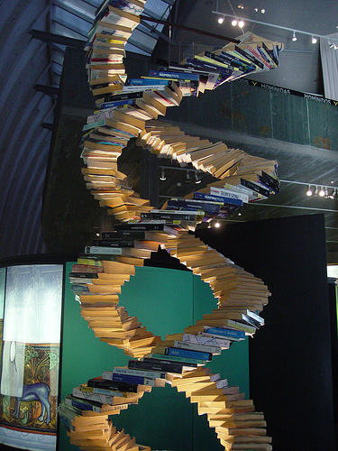

P A R T I C I P A T I O N F E E S

ensures and makes access
to Congress and received folders with papers.
The fee includes use any drinks during
coffee breaks and dinner.
The fee is 100 lei for the citizens of Moldova
and 50 euros for foreigners.
It will be paid at registration
on the opening day of Congress

CORRESPONDING ADDRESS
E-mail igcanc@yahoo.com
Institute of Genetics and Plant Physiology,
Mold. Acad. Sci.
20 Pădurii Str., Chişinău MD 2002, RM
Tel: (+37322) 66-04-24; 77-04-47
Fax: (+37322) 55-61-80
CONTACT PERSONS

- General and Molecular Genetics
Angela Port portang@yahoo.com
- Human and medical Genetics
Victoria Sacară victoriasacara@hotmail.com
- Plant Genetics and Breeding
Eugenia Cotenco dobynda@yahoo.com
- Animal Genetics and Breeding
Valentin Focşa focsa@mail.ru
- Plant and Animal Biotechnology
Aliona Glijin aglijin @yahoo.com

ACADEMY OF SCIENCE OF MOLDOVA

SCIENTIFIC SOCIETY OF
GENETICISTS AND BREEDERS
OF THE REPUBLIC OF MOLDOVA



Papers (summaries) will be published in the Congress volume, witch will be distributed to participants and those interested institutions under the limit of participation fees and counter cost.
Ordered Communications, presented at sections and at plenary will be published in the Bulletin of the ASM, Life Sciences.

WORK EDITING
Title – font 14, Times New Roman, bold; authors, affiliation – font 12, Times New Roman, italic, centered; the text – one A4 page, font 12, Times New Roman, single spacing; margins: left – 3.0 cm, top/bottom – 2.0 cm, right – 1.5 cm.
When submitting via e-mail please indicate the section where the paper is to be presented. The name of the card will coincide with the first author’s name.
Each author may contribute (author or co-author) mostly at two communications.

D E A D L I N E S

Participants registration – 01.06.2010
Work submission – 01.09.2010
The IInd Curircular Letter and Programme – 15.10.2010

ACADEMY OF SCIENCES OF MOLDOVA
and
SCIENTIFIC SOCIETY
OF GENETICISTS AND BREEDERS
OF THE REPUBLIC OF MOLDOVA
to be held
on Octomber, 21-22, 2010

THE IX-TH
INTERNATIONAL
CONGRESS

S E C T I O N S
- General and Molecular Genetics
- Human and Medical Genetics
- Plant Genetics and Breeding
- Animal Genetics and Breeding
- Plant and Animal Biotechnology

WORKING LANGUAGE

Romanian, English

ADDITIONAL INFORMATION

www.asm.md
www.edu.asm.md
www.igfp.asm.md

SCIENTIFIC COMMITTEE

Furdui T. – Academician of the Academy of Sciences of Moldova (President)
Micu V. – Academician of the ASM
(Vice- President)
Palii A. – Corr. Member of the ASM
(Vice-President)
Bucarciuc V. – Dr. hab.
Ciubotaru A. – Academician of the ASM
Dadu C. – Dr. hab.
Groppa S. – Corr. Member of the ASM

Moşin V. – Dr. hab.
Rapcea M. – Dr. hab.
Rotaru T. – Dr. hab.
Siminel V. – Corr. Member of the ASM

ORGANIZING COMMITTEE

Duca Maria – Corr. Member of the ASM, professor (Co-president)
Barbacar N. – Dr. hab., professor
(Co-president)
Toderaş Lidia – Dr.hab.
Focşa М. – Dr. hab.
Cotenco Eugenia – Dr.
Glijin Aliona – Dr.
Port Angela – Dr.
Sacară Victoria – Dr.
Vozian V. – Dr.

Jacotă A. – Academician of the ASM

